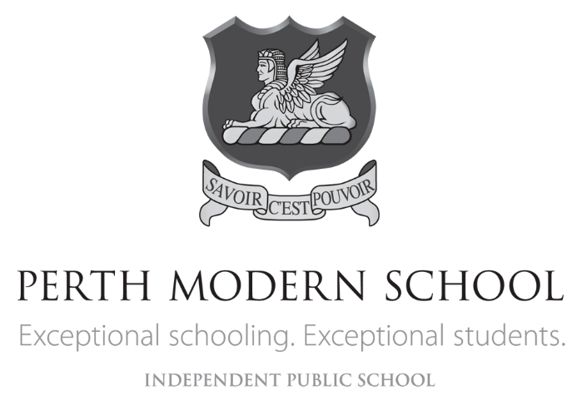

**YEAR 12 CHEMISTRY TEST 4**

**Organic Chemistry Question/Answer Booklet**

**STUDENT NAME**

**TEACHER ANSWER KEY**

**Recommended time: 50 minutes**

**Materials provided for this test**

* **Test booklet**
* **Multiple-choice Answer sheet**
* **Chemistry Data Sheet**

**STRUCTURE OF THIS TEST**

**Section One: 15 Multiple- choice questions 15 marks**

**Section two: 6 Short answer questions 35 marks**

**Section One: Multiple-choice (15 Marks)**

This section has 15 questions. Answer all questions on the separate Multiple-choice answer sheet provided. For each question, put a cross in the appropriate box to indicate your answer. Use only a blue or black pen to draw the cross. If you make a mistake, shade the box with the incorrect answer, then place a cross in the box with the new answer. Do not use correction fluid/tape. Marks will not be deducted for incorrect answers. No marks will be given if more than one answer is completed for any question.

Suggested working time: 15 minutes

1. Consider the section of the polymer below.

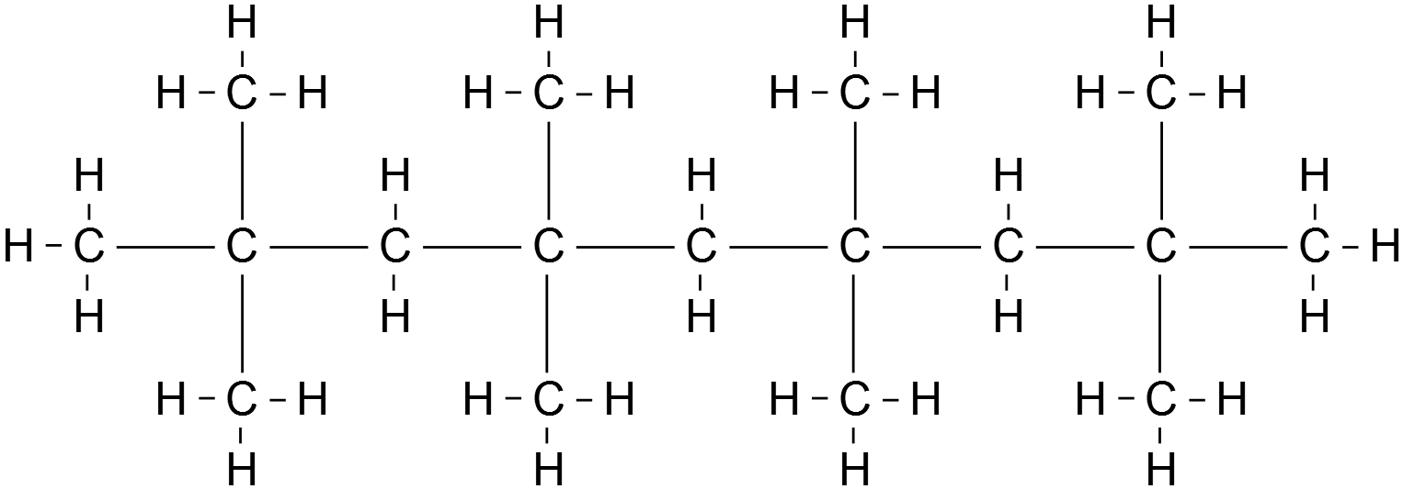

_ _ _ _

_ _ _ _

Which one of the following is the correct name for the monomer used to synthesise this polymer?

(a) but-1-ene

(b) but-2-ene

(c) methylpropene

(d) 2,2-dimethylethene

2. Substance **X** has an empirical formula of C2H4O. Which one of the following could **not** be substance **X**?

(a) butanoic acid

(b) ethyl ethanoate

(c) methyl methanoate

(d) methyl propanoate

3. Which one of the following compounds will be readily oxidised to form a carboxylic acid?

1. CH3CH2C(OH)CH3
2. HOC(CH3)3
3. CH3CH2COOCH3
4. CH3CH2CHO

4. Which one of the following pairs of compounds would form methyl propanoate when warmed with concentrated sulfuric acid?

(a) CH4 and CH3CH2COOH

(b) CH3OH and CH3CH2CH2OH

(c) CH3OH and CH3CH2COOH

(d) HCOOH and CH3CH2CH2OH

5. The two main types of polymerization reactions are addition and condensation. Which of the following polymers results from condensation polymerization?

1. Nylon.
2. Polythene.
3. Polyvinyl chloride.
4. Polybutadiene.

6. Which of the following substances would be most soluble in water ?

1. CH3CH2OCH2CH3
2. CH3CH2CH3
3. CHCl3
4. CH3CH2OH

7. Consider the molecule below.

Which one of the following will this molecule **not** react with?

(a) dilute hydrochloric acid

(b) sodium hydrogencarbonate solution

(c) sodium chloride solution

(d) sodium hydroxide solution

8. Which of the following substances is an amine?

(a) CH3CH2NO2

(b) HCOONH4

(c) CH3CH2CH2CONH2

(d) CH3NH2

9. Which of the following molecules contain(s) no double bond?

1 (CH3)2CHCH3

2 (CH3)3CCHCH2

3 CHCl2(CH2)3COOH

4 (CH3)2CHCHO

5 CH3CH2CHO

(a) 1 only

(b) 3 only

(c) 3 and 4 only

(d) 3, 4 and 5 only

10. Four compounds, W, X, Y and Z are represented below:

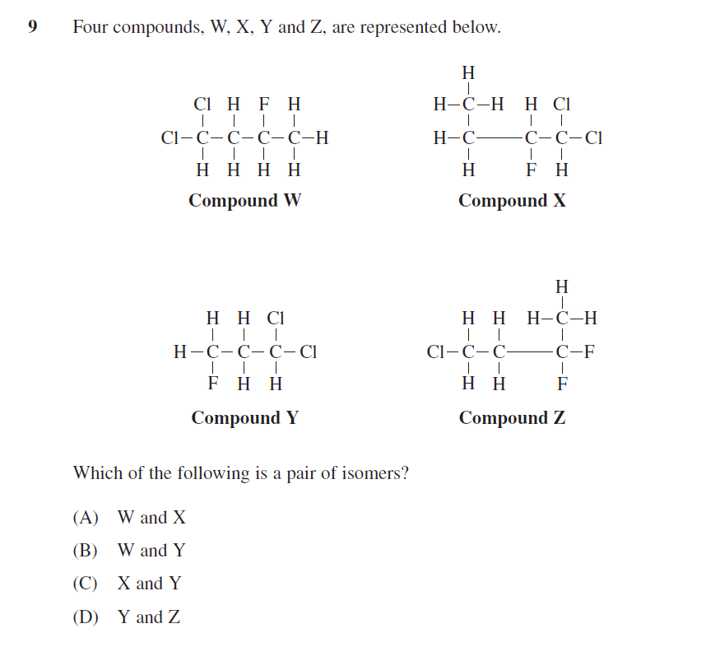

Which of the following is a pair of isomers?

1. W and X
2. W and Y
3. X and Y
4. Y and Z

11. Ethanol is removed from the body by reaction with the enzyme alcohol dehydrogenase (ADH). In fact, ADH can oxidise any alcohol. ADH, like all enzymes, is very specific and will not catalyse any other reaction. However, the product of the ADH reaction with an alcohol may undergo further reaction with other enzymes.

The reaction of butan-2-ol with ADH would produce:

1. butanal
2. butan-2-one
3. butanoic acid
4. 2-methylpropan-2-one

12. Bromine reacts with both ethane and ethene. A difference in the two reactions is:

1. Hydrogen gas is produced with ethane, but not ethene
2. Hydrogen bromide gas is produced with ethene but not ethane
3. Reaction with ethene occurs only in sunlight
4. Reaction with ethane is much slower than ethene

13. Based on the relevant structural formulae of methyl butane and dimethyl propane which of the following is the same for both compounds?

1. Molecular structure

(b) Melting point

(c) Solubility

(d) Empirical Formula

14. In a series of experiments the following observations were made about a colourless liquid.

|  |  |
| --- | --- |
| **Experiment** | **Observation** |
| Liquid was added to potassium dichromate solution | No visible reaction |
| Liquid was added to sodium metal | Colourless, odourless gas evolved, silvery solid dissolved |
| Liquid was added to ethanol and heated with concentrated sulfuric acid | Fruity smell produced |

Which one of the following substances would produce all of these observations?

(a) 2-methylbutan-2-ol

(b) butanoic acid

(c) butan-2-ol

(d) butanone

15. Which of the following statements regarding alcohols is correct?

(a) The -OH functional group on the alcohols makes them basic.

(b) The solubility of alcohols in water increases with increasing length of the hydrocarbon chain.

(c) Primary alcohols are oxidised to acids, secondary alcohols to aldehydes and tertiary alcohols to ketones.

(d) Primary alcohols have higher boiling points than secondary alcohols which have higher boiling points than tertiary alcohols.

**Section Two: Short answer (35 marks)**

This section has **SIX (6)** questions. You must answer **all** questions. Write your answers in the spaces provided

**Question 16** **[6 marks]**

In the table below, draw structural diagrams for the indicated substances:

|  |  |
| --- | --- |
| The organic product from the reaction of ethanoic acid with methanol in the presence H2SO4 solution |  |
| The cis isomer of  C4 H6Cl2 |  |
| The organic product formed when sodium metal is added to propan-1-ol |  |

|  |  |
| --- | --- |
| **Description** | **Marks** |
| Show all H’s | 1 |
| Ionic charge on C-O in part (iii) | 1 |
| One error remove one mark |  |
| **Total** | **6** |

**Question 17 (7 marks)**

Butan-2-ol can be oxidised with acidified potassium dichromate solution.

(a) Draw the structural formula and name the organic product formed. (2 marks)

|  |  |
| --- | --- |
| **Description** | **Marks** |
| Must have all C-H’s | 1 |
| Butanone | 1 |
| **Total** | **2** |

(b) (i) Draw and name an isomer of butan-2-ol that will react with potassium dichromate solution to produce a carboxylic acid. (2 marks)

|  |  |
| --- | --- |
| **Description** | **Marks** |
| OR    Must have all C-H’s | 1 |
| butan-1-ol or 2-methylpropan-1-ol | 1 |
| **Total** | **2** |

(ii) Write a balanced redox equation for this reaction. (3 marks)

*(14 H+ + Cr2O72–****+*** *6 e– → 2 Cr2+ + 7 H2O) × 2*

*(C4H9OH + H2O → C3H7COOH + 4 H+ + 4 e–) × 3*

***2Cr2O72–+ 3 C4H9OH + 16 H+ → 4 Cr2+ + 3 C3H7COOH + 11 H2O***

|  |  |
| --- | --- |
| **Description** | **Marks** |
| Correct balanced alcohol -> carboxylic acid reaction | 1 |
| Correct electron multiplication | 1 |
| Correctly balanced final equation | 1 |
| **Total** | **3** |

**Question 18 (4 marks)**

Use your knowledge of the structure and properties of organic materials to explain the following

1. Pentan-1-ol boils at a much higher temperature than pentane (2 marks)

Pentane has only Dispersion forces (weak van der Waals forces). Pentan-1-ol has hydrogen bonding and dispersion forces. Since hydrogen bonding is a stronger intermolecular force than dispersion forces, more energy is required to separate the molecules of pentan-1-ol than the molecules of pentane. Thus pentan-1-ol has a higher boiling point than pentane.

|  |  |
| --- | --- |
| **Description** | **Marks** |
| Identify main intermolecular force in pentane as dispersion **and** pentan-1-ol as hydrogen bonding | 1 |
| Compare dispersion forces as weaker to hydrogen bonding. | 1 |
| **Total** | **2** |

1. Pentan-1-ol is more soluble in water than pentanal. (2 marks)

In general, compounds with similar polarity dissolve each other (like dissolves like).

Water is highly polar and displays hydrogen bonding between its molecules.

Compounds with more polar groups and lower molar mass will be more soluble in water.

Alcohol is more polar than aldehyde. C=O of aldehyde can accept hydrogen bonds from hydrogen bond donors, but it does not donate a hydrogen bonds themselves because they lack a H directly on the O atom. Contrary to aldehyde, alcohol has the -OH group and it can both act as a Hydrogen bond donor and accepter. This advantage makes alcohol more polar, thus making it more soluble in water.

|  |  |
| --- | --- |
| **Description** | **Marks** |
| Compare polarity of alcohol vs aldehyde (C=O v O-H) | 1 |
| Intermolecular forces between water and pentanol is larger due to H-bonding | 1 |
| **Total** | **2** |

**Question 19**  **(6 marks)**

1. Complete the table below by giving a brief description and the observations of a chemical test that could be used to distinguish between propan-2-one and propanal. (3 marks)

|  |
| --- |
| Description of simple test.  Addition of acidified KMnO4 / dichromate (1 mark) |
| Observations for propan-2-one  No visible reaction (1 mark) |
| Observations for propanal  MnO4- : pink 🡪 colourless or  Dichromate : orange 🡪 green (1 mark) |

1. A scientist has put propanone into a beaker and propanoic acid into another but did not label the beakers and has forgotten which is which.

Describe **one** chemical test that could be attempted with *each* sample that would distinguish between the two liquids.

List the observations relating to the test for both propanone and propanoic acid.

(3 marks)

|  |
| --- |
| Description of simple test.  Addition of reactive metal eg magnesium / zinc (1 mark)  (Or reaction with carbonate / alcohol + acid and heat) |
| Observations for propanone  No visible reaction (1 mark) |
| Observations for propanoic acid  Bubbles of gas formed (1 mark) |

**Question 20 (4 marks)**

An organic compound has the molecular formula C5H12O. Spectroscopic analysis of this compound indicates the presence of a hydroxyl group. The compound reacts slowly with sodium producing hydrogen gas. It does not react with acidified potassium permanganate solution.

1. Name the compound and draw its structural formula. (2 marks)

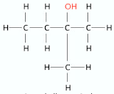

Show C-H’s

Name: 2-methybutan-2-ol

|  |  |
| --- | --- |
| **Description** | **Marks** |
| Correctly drawn with all hydrogen present | 1 |
| Correctly names. (Can also accept 2-methy-2-butanol) | 1 |
| **Total** | **2** |

1. Explain how you identified the organic compound (2 marks)

Hydroxyl group indicates – O-H bond therefore an alcohol group

Not oxidized by the permanganate solution indicates a tertiary alcohol. This is backed up by slow reaction with sodium.

|  |  |
| --- | --- |
| **Description** | **Marks** |
| Identifying alcohol functional group with reaction with sodium metal | 1 |
| Identify tertiary alcohol by not reacting with permanganate | 1 |
| **Total** | **2** |

**Question 21 (8 marks)**

1. 2-methylpropanal whose formula is (CH3)2CHCHO, has two other structural isomers. In the spaces below, draw the structural formula and the IUPAC names of these two isomers. (4 marks)

|  |  |
| --- | --- |
| Structure | IUPAC name |
|  |  |
| Butanal | Butan-2-one or Butanone |

|  |  |
| --- | --- |
| **Description** | **Marks** |
| Correct drawing for each showing all hydrogens | 2 |
| Correct name for each | 2 |
| Unsaturated alcohols acepted |  |
| **Total** | **4** |

2-methylpropanal can be converted into substance Y by heating it with acidified potassium dichromate

1. State an observation that can be made as this reaction proceeds (1 mark)

Orange 🡪 Green (1 mark)

1. Name the functional group present in substance Y that us NOT present in 2-methylpropanal (1 mark)

Carboxylic acid

1. Write a balanced half – equation showing the conversion of 2-methylpropanal into substance Y (2 marks)

(CH3)2CHCHO + H2O 🡪 (CH3)2CHCOOH + 2H+ + 2e-

|  |  |
| --- | --- |
| **Description** | **Marks** |
| Correct formula for organic product formed | 1 |
| Fully balanced equation with all correct species | 1 |
| **Total** | **2** |